Assessment of Anew Products Effeciency against Escherichia coli in Comparision with Common Artificial Antibiotics

Nihad H. Mutlaq Ali. H. Demin Eman. H. Mutlag
A.L. Ameer Abood Rouya A. Hassan Baneen N. abd zaid
Maryam M. Shakear Zahraa H. abdulreza

Abstract
The study aim to isolate , identify and characterize the Escherichia coli and look for their antibiotics resistance in children with diarrhea in najaf , the study includes 60 samples of stools gathered from patients children visiting Educational AL_Zahraa hospital for the period beginning of November 2016 to mid January of the same year, the age of these children were less than ten years , specimens were phenotypic assays , microscopically examined and diagnosed by biochemical tests , the highest bacterial pathogens isolated were Escherichia coli .
The sensitivity of isolated of E.coli (10samples) were examined for 11 types of antibiotics , E . coli exhibite different pattern of resistance to different antibiotics ,it is have highest resistance to penicillin (ampicillin and carbenicillin), and it is have higher resistance for ceftazidime and cefepime , while have moderate resistance for aztreonam.it is have lowest resistant rate to imipenem ,meropenem and ertapenem.Also the fungi filterates gave asignificant values in the inhibition of growth of E.coli in petri dish which reach 5 cm in compare with antibiotics that used in the study .
المستخلص
هدفت الدراسة الى عزل وتشخيص بكتريا القولون من براز الأطفال المرضى المصابين بالإسهال في مستشفى الزهراء التعليمي للاطفال في النجف للفترة من نوفمبر 2015 الى كانون الثاني 2016 وقد شملت الدراسة 60 عينة, وقد تراواحت اعمار الاطفال اقل من عشر سنوات, تم اجراء الفحوصات المجهرية والفحوصات الكيمو حيوية من قبل كادر المختبر المركزي في المستشفى المذكور اذ وجد ان بكتريا القولون كانت الاكثر تواجدا في عينات الدراسة. نقلت العينات الى مختبرات كلية العلوم قسم البيئة حيث تم اختبار Muller Hilton حساسية ومقاومة تلك العزلات الى 11 مضاد حيوي (على شكل اقراص) على وسط Brain heart Agar بعد ان تم تنشيطها على وسط.Agar
لقد اظهرت حساسية ومقاونة عزلات الايكولاي انماطا مختلفة تجاه المضادات الحيوية المستخدمة في الدراسة اذ اعطت اعلى مقاومة للبنسيلين (الامبسيلين والكاربنسيلين) كذلك للمضادين الحيوييين (سيفتازيديم سيفيبسم) بينما اظهرت مقاومة متوسطة للمضاد (ازتريونام) واعطت اقل مقاومة لمجموعة (اميبينيم والميروبينيم والايرتابينيم).
الا ان الفروق المعنوية اعطتها معاملة الراشح الفطري في تثبيطها لنمو بكتريا القولون المنماة على وسط مولر هنتون حيث بلغ قطر التثبيط 5 سم بالمقارنة ما اعطته المضادات الحيوية المستخدمة في الدراسة والتي لم تتجاوز 4سم .

1-Introduction
Diarrhea is a serious and widespread diseases in the world as it affects children under the age of 5 years to the disease and are concentrated injury in infants aged from six months to two years ^{[1]} . Acute diarrheal diseases are an important health problem among children under five in developing countries ^{[2]} .It has been reported that diarrheal diseases cause approximately 3 million deaths worldwide per year ^{[3a]} .
The main cause of death in severe cases of diarrhea due to dehydration resulting from the loss of body fluids necessary. Because whatever is causing the diarrhea malnutrition Therefore, diarrhea and malnutrition are among the main reasons for the occurrence of deaths in many countries ^{[4]} . The pathogen of many of them : such as bacterial like Escherichia coli ,Salmonella spp, Shigella spp and Campyiobacter and Viral like Rota virus ,Corona virus and Adeno virus as well as the etiology parasitic infections, and the most important Entamoeba histolytica and Giardia lamblia and yeasts such as Candida albicans ^{[5]} .
Come diarrhea as a result of the entry of pathogens to gastrocoele for children through the food and drinks and hands contaminated with those pathogens or as a result of turning some members of normal flora to etiology, acceptable to the increasing percentage of the normal limit due to a change in the intestinal environment as a result of eating certain drugs or injury the child in one of aetiology making it easier for these microorganism to events the disease ^{[6]} .
Among the bacterial pathogens E. coli plays an important role in causing diarrhea in children .
EPEC (Enteropathogenic E. coli ) is an important category of diarrheagenic E. coli which has been linked to infant diarrhea in developing world^{[7]} . Five different pathotypes of diarrheagenic E .coli are well recognized based on their patterns of gastrointestinal disease: enteropathogenic E. coli (EPEC), entero-toxigenic E. coli (ETEC), Shiga toxin-producing E. coli (STEC),enteroaggregative E. coli (EAEC) and enteroinvasive E. coli (EIEC) ^{[8]} .
Escherichia coli is a Gram-negative, facultatively anaerobic,non sporing rod-shaped bacterium of the genus Escherichia that is commonly found in the lower intestine of warm-blooded organisms (endotherms).^{[9][10].} Cells are typically about 2.0 micrometers (μm) long and 0.25–1.0 μm in diameter, with a cell volume of 0.6–0.7 μm³.^{[11][12][13]} .Most E. coli strains are harmless, but some serotypes can cause serious food poisoning in their hosts, and are occasionally responsible for product recalls due to food contamination.^{[14][15]} The harmless strains are part of the normal flora of the gut, and can benefit their hosts by producing vitamin K₂,^{[16]} and preventing colonization of the intestine with pathogenic bacteria.^{[17][18]} E . coli is expelled into the environment within fecal matter. The bacterium grows massively in fresh fecal matter under aerobic conditions for 3 days, but its numbers decline slowly afterwards.^{[19]}
E. coli and other facultative anaerobes constitute about 0.1% of gut flora,^{[20]} and 2%fecal–oral transmission is the major route through which pathogenic strains of the bacterium cause disease. Cells are able to survive outside the body for a limited amount of time, which makes them potential indicator organisms to test environmental samples for fecal contamination.^{[21][22]} A growing body of research, though, has examined environmentally persistent E. coli which can survive for extended periods outside of a host^{[23]} .The bacterium can be grown and cultured easily and inexpensively in a laboratory setting, and has been intensively investigated for over 60 years. E. coli is a chemoheterotroph whose chemically defined medium must include a source of carbon and energy. Organic growth factors included in chemically defined medium used to grow E. coli includes glucose, ammonium phosphate, mono basic, sodium chloride, magnesium sulfate, potassium phosphate, dibasic, and water. The exact chemical composition is known for media that is considered chemically defined medium.^{[24]} E. coli is the most widely studied prokaryotic model organism, and an important species in the fields of biotechnology and microbiology, where it has served as the host organism for the majority of work with recombinant DNA. Under favorable conditions, it takes only 20 minutes to reproduce.^{[25]}
Antibiotic treatment of common bacterial infections plays a crucial role in reducing morbidity and mortality due to these disease, however, over use and misuse of antibiotics in the treatment of diarrhea could lead to increased antibiotic resistance ^{[3b]} . In this context a study was undertaken to isolate, identify and characterize the E. coli pathotypes and their antibiotic resistance in children less than 10 years with diarrhea in Najaf/Iraq, among these antibiotics were used includes:
Ampicillin is an antibiotic used to prevent and treat a number of bacterial infections.^{[26]} This includes respiratory tract infections, urinary tract infections, meningitis, salmonella infections, and endocarditis. It may also be used to prevent group B streptococcal infection in newborns. It is used by mouth, by injection into a muscle, or intravenously.^{[26]} Common side effects include rash, nausea, and diarrhea. It should not be used in people who are allergic to penicillin.
Ceftazidime is an antibiotic useful for the treatment of a number of bacterial infections. It is a third-generation cephalosporin.As a class, cephalosporins have activity against Gram-positive and Gram-negative bacteria. The balance of activity tips toward Gram-positive organisms for earlier generations; later generations of cephalosporins have more Gram-negative coverage ^{[29]}
Colistin (polymyxin E) is a polymyxin antibiotic produced by certain strains of Paenibacillus polymyxa var. colistinus. Colistin is a mixture of cyclic polypeptides colistin A and B. Colistin is effective against most Gram-negative bacilli and is used as a polypeptide antibiotic^{[ 34.35]}.
Carbenicillin is a bactericidal antibiotic belonging to the carboxypenicillin subgroup of the penicillins.
It has Gram-negative coverage which includes Pseudomonas aeruginosa but limited Gram-positive coverage. The carboxypenicillins are susceptible to degradation by beta-lactamase enzymes, although they are more resistant than ampicillin to degradation. Carbenicillin is also more stable at lower pH than ampicillin^{[40]}.
Chloramphenicol is an antibiotic useful for the treatment of a number of bacterial infections. This includes meningitis, plague, cholera, and typhoid fever ^{[42] .} It is available intravenously, by mouth, and as an eye ointment.^{[41][43]} .Common side effects include bone marrow suppression, nausea, and diarrhea. The bone marrow suppression may result in death.
Cefepime is a fourth-generation cephalosporin antibiotic. Cefepime has an extended spectrum of activity against Gram-positive and Gram-negative bacteria, with greater activity against both types of organism than third-generation agents^{[47]}
Tetracycline is an antibiotic used to treat a number of bacterial infections. It is commonly used to treat acne and rosacea
Tetracyclines have a broad spectrum of antibiotic action. Originally, they possessed some level of bacteriostatic activity against almost all medically relevant aerobic and anaerobic bacterial genera, both Gram-positive and Gram-negative, with a few exceptions, such as Pseudomonas aeruginosa and Proteus spp
Aztreonam (trade names Azactam injection, Cayston inhalation) is a monobactam antibiotic used primarily to treat infections caused by gram-negative bacteria .Aztreonam has strong activity against susceptible Gram-negative bacteria, including Pseudomonas aeruginosa. It has no useful activity against Gram-positive bacteria or anaerobes. It is known to be effective against a wide range of bacteria,includingCitrobacter, Enterobacter, E.coli, Haemophilus, Klebsiella, Proteus, and Serratia species.^{[49]}
Ertapenem has been designed to be effective against Gram-negative and Gram-positive bacteria.
It is not active against MRSA,ampicillin-resistant enterococci, Pseudomonas aeruginosa, or Acinetobacter species. Ertapenem also has clinically useful activity against anaerobic bacteria.
There are a few adverse effects of ertapenem like confusion and headache, which may worsen to convulsions and seizures the manufacturers cannot comment on its safety in pregnancy. ^{[50]}
Imipenem (Primaxin) is an intravenous β-lactam antibiotic^{[51]} It was the first member of the carbapenem class of antibiotics. Carbapenems are highly resistant to the β-lactamase enzymes produced by many multiple drug-resistant Gram-negative bacteria,^{[52]} Meropenem It is a β-lactam and belongs to the subgroup of carbapenem, similar to imipenem and ertapenem^{[55][56]} The spectrum of action includes many Gram-positive and Gram-negative bacteria (including Pseudomonas) and anaerobic bacteria ^{[57]} .
The distinctive role of the fungus P.o in the fighting against many pathogens as well as improvement plant growth and productivity, as the fungus worked to reduce the incidence and severity of radicals disease caused by fungus Fusarium spp in tomato, eggplant, potato , pean , wheat and rice plants (AL-Rawi, 1997 and Zobaie, 2000 and Harman, 2000 and Sarhan Jasim, 2000, Abdul Aziz, 2001), the mechanisms that used by T.harzianum fungus in the fight against diseases were paratisim, enzymes secretion (Chitinase , Cellulase , Protease , β-1,3gluconase), antagonisim, production of antibiotics (Trichodermol ,Trichodermin , Pachybasi Gliotoxine , Emodin Chrysophancol) ,compotition and plant growth inducing (Limon et al, 1999 and Harman et al,2004).
2-Materials and Methods
Study was carried out at Educational Al-Zahraa hospital and microbiology laboratory / college science / university of kufa in Najaf during 2016 , IRAQ . Children in the age group of less than 10 years , suffering from diarrhea and suspected Escherichia coli .
2-1-Sample collection :
Stool specimens were collected from the children with diarrhea under 10 years of age over a period of approximately 3 months . The samples were collected in disposable sterilized seal- leak containers containing transport solution Carry Blair transport medium (is a semisolid medium recommended for use in the transportation and preservation of clinical specimens , primarily stool and rectal swabs).
2-2-Sample analysis :
The specimen was cultured according to standard method .In order to evaluate the role of E.coli small amount of each samples were cultured initially on MacConky Agar and incubated for 24 hrs. at (35-37C) ,the remainder stool from each samples inoculated into Selinite Broth for detection of pathogenic bacteria and incubated tubes for 24hrs. at (35_37C) . On second day read results macroscobically for E.coli on MacConky Agar which appears pink in color , the specimens were checked microscopically by Gram stain which appear negative Bacilli and diagnosed by biochemical tests (IMVIC) which incubated for 24hrs. at (35-37C)and read the results in third day , transport specimen from Selinite Broth to XLD and incubated 24 hrs. at (35-37C) for detection the presence of other pathogenic bacteria such as(Salmonella , Shigella) .
On third day , the biochemical tests (MIVIC) performed for the specimens isolated from XLDand incubated for 24hrs. at(35-37C),read the results in the fourth day which appear dry yellow colonies and compared with the result of the first (IMVIC).
On fourh day ,done the final steps of diagnosis (biochemical reaction) on the samples from both XLD and MacConky Agar ,compared the results , which includes :
A-Kliger Iron Agar , red in color which became acid bottom/acid slant give gas but no H₂S .
B-Urea , yellow in color which give negative result because E.coli lack Ureas enzyme.
C-Indol , palle yellow in color which give positive result and produced red ring after incubated one day and added dropes from indicater for it .
D-Monitol Salt Broth that blue in color became yellow with mortility .
NOTE/ result of final steps of biochemical tests read after incubation for 24 hrs. at(35-37C).

Table (2) Biochemical tests of E.coli Isolates
E.coli(11 isolates) | Test
- | Gram stain
- | Catalase
- | Oxidase
- | H2S
+ | Indole
+ | Methyl red
- | Vogasproskauer
- | Citrate utilization
- | Urease
+ | Motility
+ | Lactose
+ | Acid from glucose
+ | Sucrose

Transport and activate of isolated specimens :
The isolated specimens of E. coli placed in Nutrient Broth in order to preserve the microorganism (E. coli) from decay for certain period were transported into microbiological laboratory /college science / university of kufa and activate the bacteria (10 isolates) by cultured on Brain heart Agar (37mg per 1000ml ; used 9.25mg per 250ml) , incubated for 24 hrs. at (35-37C).
2-5-Antibiotic sensitivity assay :
Antibiotic sensitivity assay was performed by using 11 types of antibiotic discs includes : Cefapime ,Tetracycline , Aztreonam ,Ampicillin , Colistin Sulphate , Ceftazidim ,Carbenicillin ,Chloramphenicol 30 , Ertapenem , Imipenem , Meropenem after cultured E. coli on Muller Hilton Agar (mg per 1000ml ; used 9.5mg per 250ml) and read the results after incubation of 24 hrs. at (35-37c).
2-6-Addition of fungi filterates : To the petridish that swapped with E.coli and with some of antibiotics which used in this study( fungi filterate prepared by Dr.Nihad .H.) in order to inhibit the growth of E.coli.

Table (3) : The antibiotics used in this study

Antibiotic class | Agent used | Symbol | Content | Origin
Penems | Imipenem | IMP | 10 | BioMaxima
 | Meropenem | MEM | 10 | BioMaxima
 | Ertapenem | ETP | 10 | BioMaxima
Cephems | Cefepime | FEP | 30 | BioMaxima
 | Ceftazidime | CAZ | 30 | BioMaxima
Penicillins | Ampicillin | AM | 10 | Bioanalyse
 | Carbenicillin | PY | 100 | Bioanalyse
Monobactams | Aztreonam | ATM | 30 | Bioanalyse
Tetracyclines | Tetracycline | TE | 30 | BioMaxima
Phenicols | Chloramphenicol | C | 30 | Bioanalyse
Polymyxins | Colistin sulphate | CT | 10 | BioMaxima

Antimicrobial susceptibility testing of β -lactam resistant E. coli isolates was performed on Mueller-Hinton agar plates by using (Kirby-Bauer) disk diffusion method against antibiotic listed in (Table 1-1). The cultures were incubated at 37°C for 18 hrs. under aerobic conditions and bacterial growth inhibition zones diameter were measured and interpreted in accordance with the Clinical and laboratory Standards Institute (CLSI) guidelines (CLSI, 2010). E. coli TOP-10 was used as the reference strain for antibiotic susceptibility testing.
3-Results :
3-1-Antibiotic Susceptibility Tests of E.coli Isolates
As determined by disk-diffusion method, all E. coli isolates exhibited different pattern of resistance to different antibiotic agents (Figur1-1), demonstrating highest resistance to penicillins (ampicillin and carbenicillin) with rate of resistance of (75% and62.5% ) isolates, respectively.
Resistance to other drug classes varied among the isolates. For cephalosporin antibiotics, a higher resistance was also detected with (75%) of isolates being resistant to ceftazidime and cefepime. The results also revealed that were moderate resistant rates (50%) isolates for aztreonam of monobactam's antibiotics.
For the carbapenem antibiotics, imipenem , meropenem and ertapenem displayed the lowest resistant rate (0%) isolates.
Percentages of resistance of isolates to the remaining antibiotics were as follows : (50%) for tetracycline, chloramphenicol (12.5%) , Colsitin sulphate (62.5%) . Results revealed that some tested isolates were resistant to a minimum 3 classes of antibiotics, hence these isolates were considered to be multidrug resistant.
The important results that obtained figure (1) were the resistance of E.coli against the IMP,MEM, ETP ,so it must pay attention that this antibiotics were useless therapy as an important components in manufacturing midicines , also this antibiotics had ahighest sensitivity against E.coli bacteria.

Figure (1): Antibiotics Resistance of E. coli isolates by disk diffusion method

Figure (1): Antibiotics Intemediate of E. coli isolates by disk diffusion method

Figure (1): Antibiotics Sensitive of E. coli isolates by disk diffusion method

Figure (4) : Total Antibiotics susceptibility profile of E. coli isolates by disk

diffusion method (IMP, Imipenem ; MEM, Meropenem ; ETP, Ertapenem ; FEP , Cefepime ; CAZ, Ceftazidime ; AM, Ampicillin ; PY, Carbenicillin ; ATM, Aztreonam ; TE, Tetracycline ; C, Chloramphenicol ; CT, Colistin sulphate).
3-2.Addition of fungi filterates to petridish cotain E. coli.
The results appearse that the antibiotics TE,AM,MEM,IP gave different inhibition diameters against E.coli which reach ( 4.4.3.4) cm respectively ,while FEP antibiotic not effect on growth of this bacteria ,in another hand asignificant result was obtained that the fungus filtrates gave ahigher inhibition zone in compare with above treatment (E.coli +Antibiotic) which also compare with control treatment table(5) ,so it mean

Table(5) Effect of addition of fungi filterates on inhibition of groth of E.coli on petri dish.
 | Inhibition Diameter(cm|)
Antibiotic | TE | FEP | AM | MEM | IP
E.coli +Antibiotic | 4 | 0 | 4 | 3 | 4
 | (Three Riplicates|)
Fungi filtrate | 5

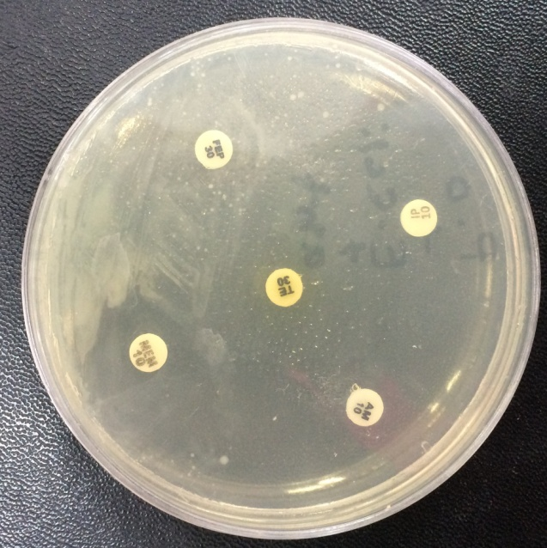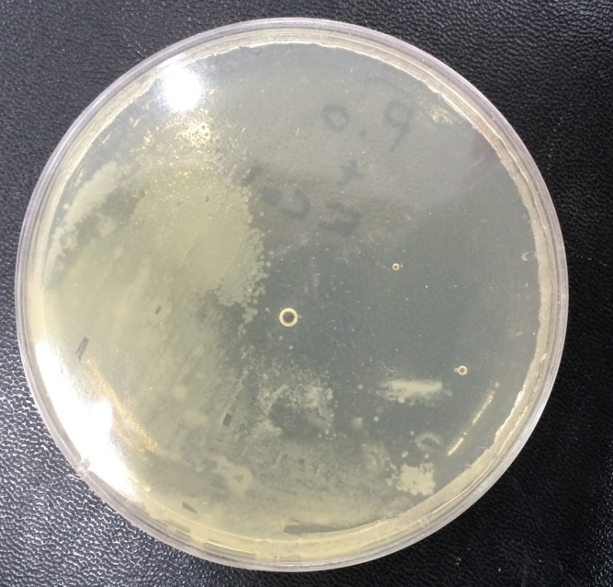
Antibiotic + E.coli Fungi filterate+ E.coli
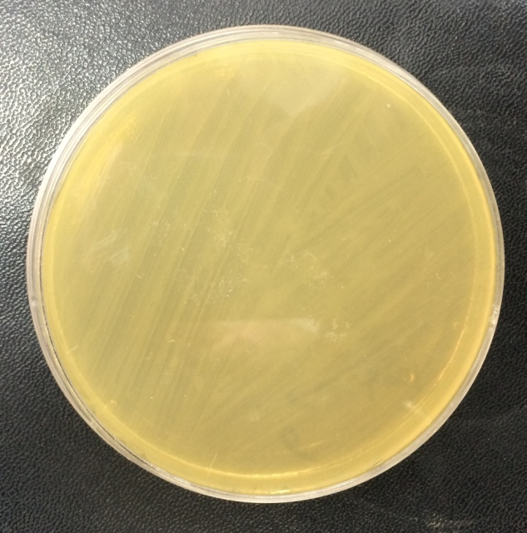
E.col

Conclusion
The result and discussion of our study’s research leads us to that “Ability to manufacture anew therapy for E.coli control”, and we arrived to these conclusions:
- Diarrhea is a serious and widespread diseases in the world as it affects children under the age of 5 years in Al-Najaf province .
- There were some of antibiotics were useless for E.coli remediation .
- Utilizing fungi filtrates for E.coli treatment with or with out the antibiotic that used in our study.
Recommendation
- Provide hospital medical pharmicies about the useless antibiotics and publish official informations (Appendix) about it.
- Establishing educational programs about retesting aprevious therapies.
- Advise people to following the healthy ways to avoid diarrhea daily.
- Application of lifestyle modification that should be availability ahealthy environment.
- Further studies should be done to explore other factors associated with diarrhea.
- Addition anew pharmaceutical technology for manufacturing anew generation of therapy.

References
1- AL-Kaby ,F.J.(2000).Astudy on diarrhea in relation to malnutrion in children under 2 years in Baghdad . ,M.se.Thesis stbmitted of the college of medicine university of AL-Mustansiriya.
2-(Rodas et al., 2011).
3-a:(Jafari et al., 2008).
b: (Jafariet al., 2009)
4- Ribeiro H.J.(2000). Diarrheal disease in a developing nation .Am.J.gastroenterol.95(1):514515
5-Jawetz E., Mechnick J.L.,Adelbreg E.A.,Brooks G.F.,Butel J.S.,and Morse S.A(2004) Medical microbiology .23th ed . McGraw-Hill Education .Singapore .ISBN007-12398-9.
6-- Pabst W.L.,M.Altwegg, C. Kind,S.Mirjanic,D.Hardegger and D.Nadal .(2003) .Prevalence of enterroaggregative E. coli among children with and without diarrhea in Switzerland .J.Clin.Microbiol.41:2289-2293
7-(AL-Hilali and Almohana , 2011)
8-(Aranda et al., 2004; Persson et al., 2007).
9- Singleton P (1999). Bacteria in Biology, Biotechnology and Medicine (5th ed.). Wiley. Pp. 444–454. ISBN 0--4---0-471-98880-4. 10- 1%%1%1%"E.Coli". Redorbit. Retrieved 27 November 2013.
11-"Facts about E. Coli: dimensions, as discussed in bacteria: Diversity of structure of bacteria: – Britannica Online Encyclopedia". Britannica.com. Retrieved 2015-06-25.
12-Yu AC, Loo JF, Yu S, Kong SK, Chan TF (2014). "Monitoring bacterial growth using tunable resistive pulse sensing with a pore-based technique". Appl Microbiol Biotechnol. 98: 855–862. Doi:.%---9.---10.1007/s00253-013-5377-9. PMID 24287933.
13- Kubitschek HE (Jan 1990). "Cell volume increase in Escherichia coli after shifts to richer media". Journal of Bacteriology 172 (1): 94–101. PMC 208405. PMID 2403552.
14- "Escherichia coli". CDC National Center for Emerging and Zoonotic Infectious Diseases. Retrieved 2012-10-02.
15- Vogt RL, Dippold L (2005). "Escherichia coli O157:H7 outbreak associated with consumption of ground beef, June-July 2002". Public Health Reports 120 (2): 174–8. PMC 1497708. PMID 15842119.
16-Bentley R, Meganathan R (Sep 1982). "Biosynthesis of vitamin K (menaquinone) in bacteria". Microbiological Reviews 46 (3): 241–80. PMC 281544. PMID 6127606.
17-Hudault S, Guignot J, Servin AL (Jul 2001). "Escherichia coli strains colonising the gastrointestinal tract protect germfree mice against Salmonella typhimurium infection". Gut 49 (1): 47–55. Doi:.%..%...10.1136/gut.49.1.47. PMC 1728375. PMID 11413110.
18- Reid G, Howard J, Gan BS (Sep 2001). "Can bacterial interference prevent infection?". Trends in Microbiology 9 (9): 424–428. Doi:.%-%-1.-)-10.1016/S0966-842X(01)02132-1. PMID 11553454.
19- Russell JB, Jarvis GN (2001). "Practical mechanisms for interrupting the oral-fecal lifecycle of Escherichia coli". Journal of Molecular Microbiology and Biotechnology 3 (2): 265–72. PMID 11321582.
20 - Eckburg PB, Bik EM, Bernstein CN, Purdom E, Dethlefsen L, Sargent M, Gill SR, Nelson KE, Relman DA (Jun 2005). "Diversity of the human intestinal microbial flora". Science 308 (5728): 1635–8. Bibcode:..2005Sci...308.1635E. Doi:.%2%.10.1126/science.1110591. PMC 1395357. PMID 15831718.
21-Feng P, Weagant S, Grant, M (2002-09-01). 4%%4%4%"Enumeration of Escherichia coli and the Coliform Bacteria". Bacteriological Analytical Manual (8th ed.). FDA/Center for Food Safety & Applied Nutrition. Retrieved 2007-01-25.
22-Thompson, Andrea (2007-06-04). "E. Coli Thrives in Beach Sands". Live Science. Retrieved 2007-12-03.
23-Ishii S, Sadowsky MJ (2008). "Escherichia coli in the Environment: Implications for Water Quality and Human Health". Microbes and Environments / JSME 23 (2): 101–8. Doi:.%2.%.2.10.1264/jsme2.23.101. PMID 21558695.
24- Tortora, Gerard (2010). Microbiology: An Introduction. San Francisco, CA: Benjamin Cummings. Pp. 85–87, 161, 165,. ISBN 0--2---0-321-55007-2.
25- "Bacteria". Microbiologyonline. Retrieved 27 February 2014.26-"Ampicillin". The American Society of Health-System Pharmacists. Retrieved Aug 1, 2015.
29-Sharma M, Pathak S, Srivastava P (October 2013). "Prevalence and antibiogram of Extended Spectrum β-Lactamase (ESBL) producing Gram negative bacilli and further molecular characterization of ESBL producing Escherichia coli and Klebsiella spp". J Clin Diagn Res 7 (10): 2173–7. doi:.%2%F.%./.10.7860/JCDR/2013/6460.3462. PMC 3843424. PMID 24298468.
31-Falagas ME, Grammatikos AP, Michalopoulos A (October 2008). "Potential of old-generation antibiotics to address current need for new antibiotics". Expert review of anti-infective therapy 6 (5): 593–600. doi:.%F...%./...10.1586/14787210.6.5.593. PMID 18847400.
32-Kumarasamy KK, Toleman MA, Walsh TR, Bagaria J, Butt F, Balakrishnan R, Chaudhary U, Doumith M, Giske CG, Irfan S, Krishnan P, Kumar AV, Maharjan S, Mushtaq S, Noorie T, Paterson DL, Pearson A, Perry C, Pike R, Rao B, Ray U, Sarma JB, Sharma M, Sheridan E, Thirunarayan MA, Turton J, Upadhyay S, Warner M, Welfare W, Livermore DM, Woodford N (2010). "Emergence of a new antibiotic resistance mechanism in India, Pakistan, and the UK: a molecular, biological, and epidemiological study". The Lancet Infectious Diseases 10 (9): 597–602. doi:.%-%%-2.-()-10.1016/S1473-3099(10)70143-2. PMC 2933358. PMID 20705517.
33--%%-7%1"Emergence of plasmid-mediated colistin resistance mechanism MCR-1 in animals and human beings in China: a microbiological and molecular biological study - The Lancet Infectious Diseases". www.thelancet.com. doi:.%-%%-7.-()-10.1016/S1473-3099(15)00424-7. Retrieved 2015-11-19.
36-Koch-Weser J, Sidel VW, Federman EB, Kanarek P, Finer DC, Eaton AE (1970). "Adverse effects of sodium colistimethate. Manifestations and specific reaction rates during 317 courses of therapy". Annals of Internal Medicine 72 (6): 857–68. doi:.%F----%./----10.7326/0003-4819-72-6-857. PMID 5448745.
37-Ledson MJ, Gallagher MJ, Cowperthwaite C, Convery RP, Walshaw MJ (1998). "Four years' experience of intravenous colomycin in an adult cystic fibrosis unit". Eur Respir J 12 (3): 592–94. doi:.%F..%./..10.1183/09031936.98.12030592. PMID 9762785. 38-Li J, Nation RL, Milne RW, Turnidge JD, Coulthard K (2005). "Evaluation of colistin as an agent against multi-resistant Gram-negative bacteria". Int J Antimicrob Agents 25 (1): 11–25. doi:.%..%...10.1016/j.ijantimicag.2004.10.001. PMID 15620821
39-Beringer P (2001). "The clinical use of colistin in patients with cystic fibrosis". Current Opinion in Pulmonary Medicine 7 (6): 434–440. doi:.%F--%./--10.1097/00063198-200111000-00013
40-http://www.toku-e.com/Assets
41- Woods, Adrienne L. (2008). 8%Delmar nurse's drug handbook. (2009 ed.). Clifton Park, N.Y.: Delmar. p. 296. ISBN 9781428361065.
42- "Chloramphenicol". The American Society of Health-System Pharmacists. Retrieved Aug 1, 2015.
45- Carone, BR; Xu, T; Murphy, KC; Marinus, MG (Jan 2014). "High incidence of multiple antibiotic resistant cells in cultures of in enterohemorrhagic Escherichia coli O157:H7.". Mutation research 759: 1–8. doi:.%..%...10.1016/j.mrfmmm.2013.11.008. PMID 24361397.
46- Moore, AM; Patel, S; Forsberg, KJ; Wang, B; Bentley, G; Razia, Y; Qin, X; Tarr, PI; Dantas, G (2013). "Pediatric fecal microbiota harbor diverse and novel antibiotic resistance genes.". PLoS ONE 8 (11): e78822. doi:.%2%.10.1371/journal.pone.0078822. PMC 3827270. PMID 24236055.
47- yahav D, Panl M, Fraser A, Sarid N, Leiporici L (2007). “Efficacy and safty of cefepime: a systematic review and meta-analysis”. Lancet Infect Dis 7 (5): 338-48.doi: 10. 1016/S1473-3099(07)70109-3. PMID 17448937
48-http://www.toku-e.com/Assets/MIC/Tetracycline%20hydrochloride.pdf
49- Mosby's Drug Consult 2006 (16 ed.). Mosby, Inc. 2006.
50- Papp-Wallace KM, Endimiani A, Taracila MA, Bonomo RA (November 2011). "Carbapenems: past, present, and future". Antimicrob. Agents Chemother. 55 (11): 4943–60. doi:.%-%.-10.1128/AAC.00296-11. PMC 3195018. PMID 21859938.
51- U.S. Patent 4,194,047
52-Clissold, SP; Todd, PA; Campoli-Richards, DM (Mar 1987). "Imipenem/cilastatin. A review of its antibacterial activity, pharmacokinetic properties and therapeutic efficacy.". Drugs 33 (3): 183–241. doi:.%F--%./--10.2165/00003495-198733030-00001. PMID 3552595
55-Edwards, JR; Turner, PJ; Wannop, C; Withnell, ES; Grindey, AJ; Nairn, K (February 1989). "In vitro antibacterial activity of SM-7338, a carbapenem antibiotic with stability to dehydropeptidase I". Antimicrobial Agents and Chemotherapy 33 (2): 215–22. doi:.%..%...10.1128/AAC.33.2.215. PMC 171460. PMID 2655530.

